Volkswagen Golf MK7.5 Facelift Heated Windscreen Retrofit
Credits:
First of all I would like to thank Altay a German enthusiast which provided me an OEM cable (when there wasn't any on Aliexpress) and a guide for the retrofit, this one is actually a further improvement to show step by step what needs to be done.
Circuit diagram
5 wires to be connected:
- 1 4mm2 wire from fuse box b (inside engine bay) terminal 30 to a new fuse SB14 (40A)
- 1 4mm2 wire from a new fuse SB14 (40A) to the relay J47
- 1 0.5mm2 wire from fuse SB17 (or any one spare in the same column) to the relay J47
- 1 0.5mm2 wire from BCM Plug B Pin 26 (inside vehicle cabin at the left of the clutch pedal) to the relay J47
- 1 4mm2 wire from the relay J47 to the 2 plugs connected to the heated windscreen (under the wiper arm blades)

- 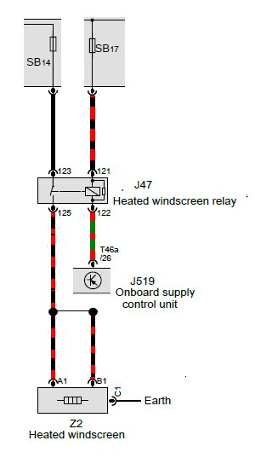

Fuse Box B Position and labels (Engine bay)
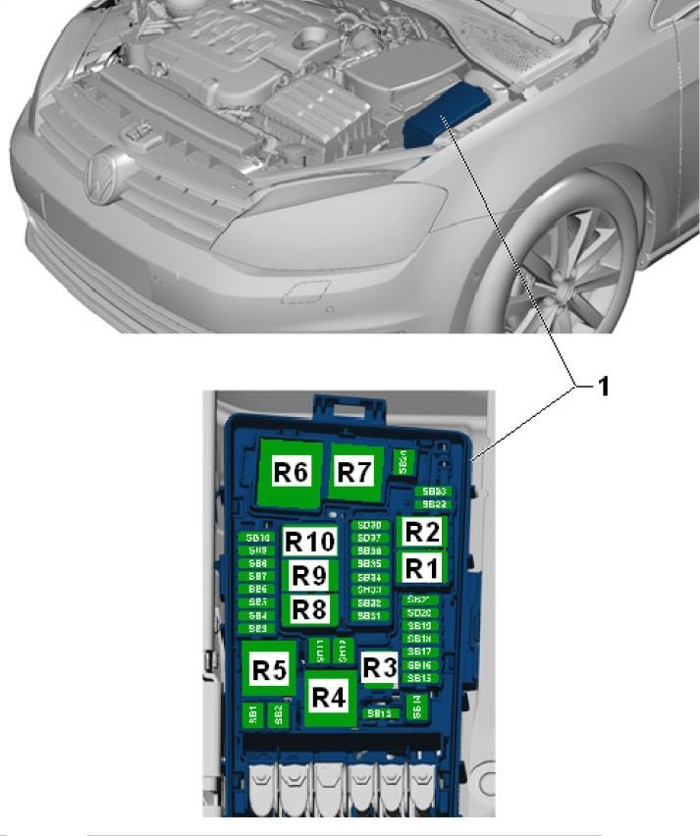

Fuse Box Terminal table
Part # | Wire size [mm²]
928990-1 | 0.2 - 0.35mm²
N90732603 | 0.5 - 1.0mm²
N90732703 | 1.5 - 2.5mm²
N90696603 | 4mm²
N90422102 | 6mm²
What you need to buy
- A heated windscreen, the most complete windscreen is 5G0845011ARNVB which is heated and has both the camera and rain/light sensor support.

- 1 relay plate 5Q0937507B (https://www.lllparts.co.uk/product/s...pn/5q0937507b7) if you fuse box b does not have it
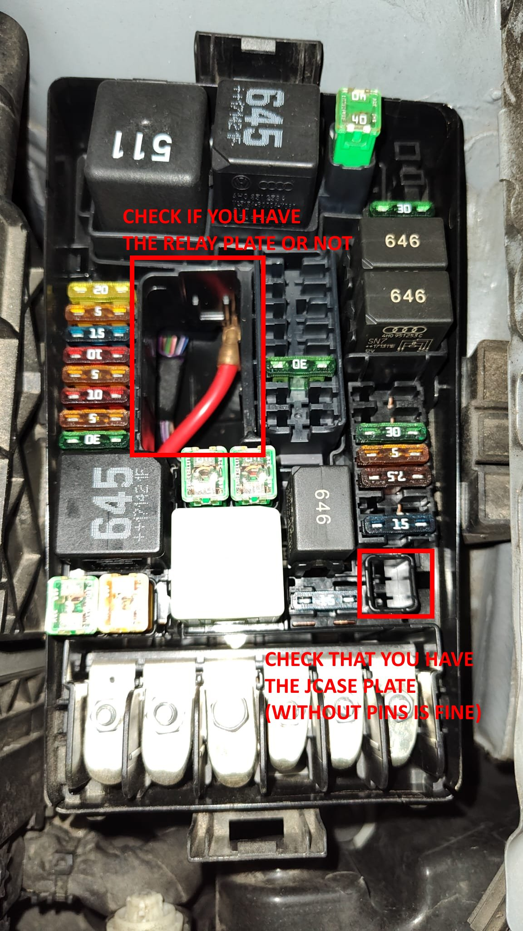
Relay plate
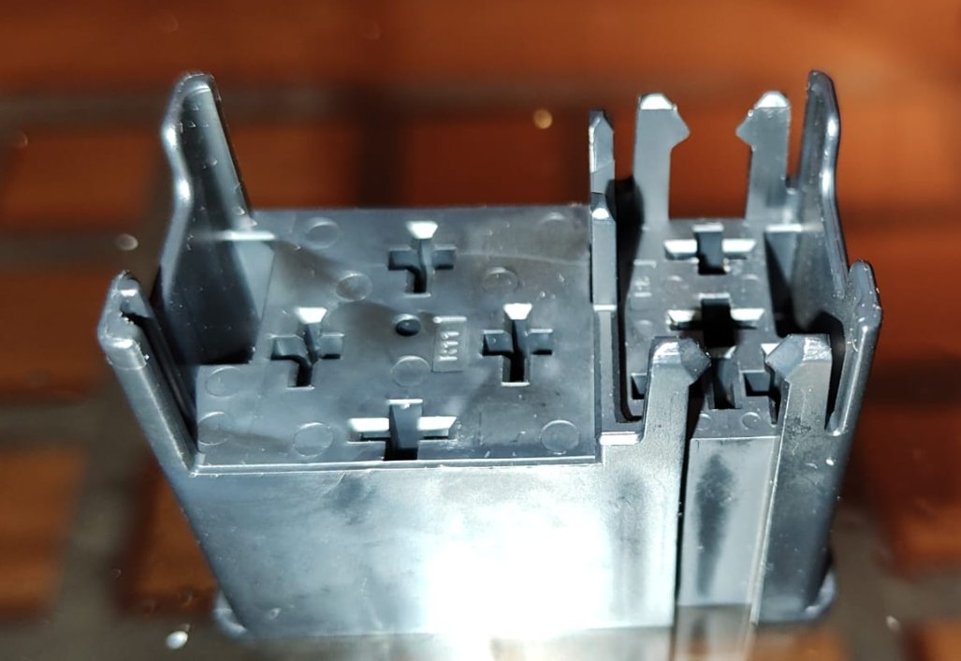
- 1 VW 3B0919136A bracket for connector housing (to secure passenger heated windscreen plug)
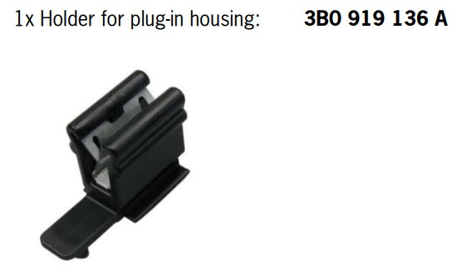

- 1 VW 3C1971303 bracket for flat cable heated windscreen (to secure driver flat cable of heated windscreen, diagram https://www.lllparts.co.uk/product/3...able-3c1971303)
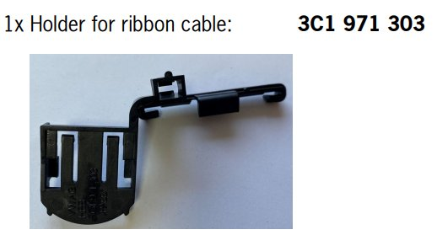
- 1 VW 3AB971890 bracket for connector housing (to secure driver heated windscreen plug)
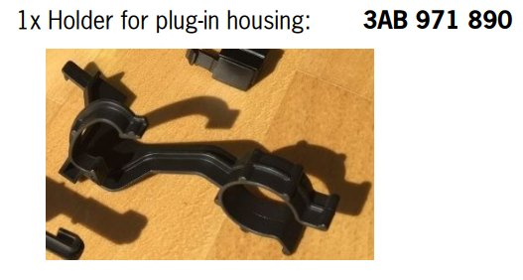
- 1 VW N90681301 clip (to secure the driver wire of the heated windscreen plug)
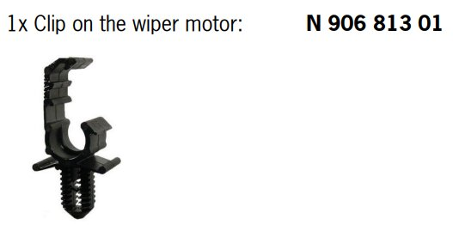
- 1 VW 5G0971848A cable holder (to secure the driver wire of the heated windscreen plug)
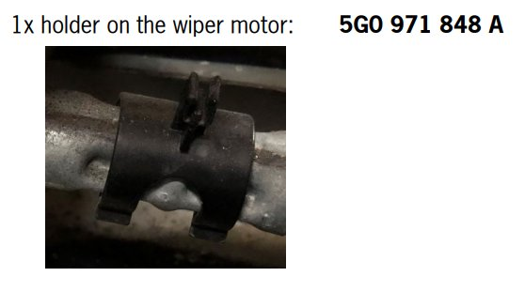
- A heated windscreen wiring harness (https://www.aliexpress.com/item/1005006436695401.html), when I started the retrofit there wasn't any cable set available, yet I found on a German forum an enthusiast which made me an OEM cable (https://www.kleinanzeigen.de/s-anzei...85171-223-8450). Just in case you want to assemble it by yourself, the wiring harness is made up of:
  - 1 40A JCASE tall/standard cartridge female fuse (SB14) + 2 male terminals (I was unable to find the part number of these)
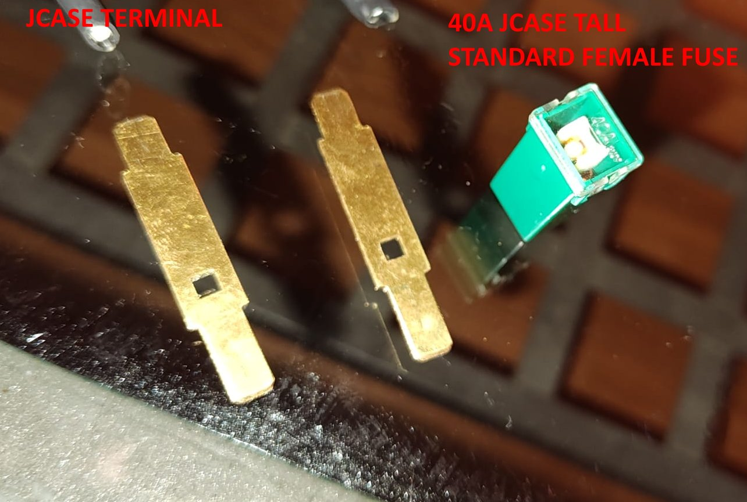

  - 1 VW 4H0951253A or compatible , 645 4 pin relay supporting at least 40A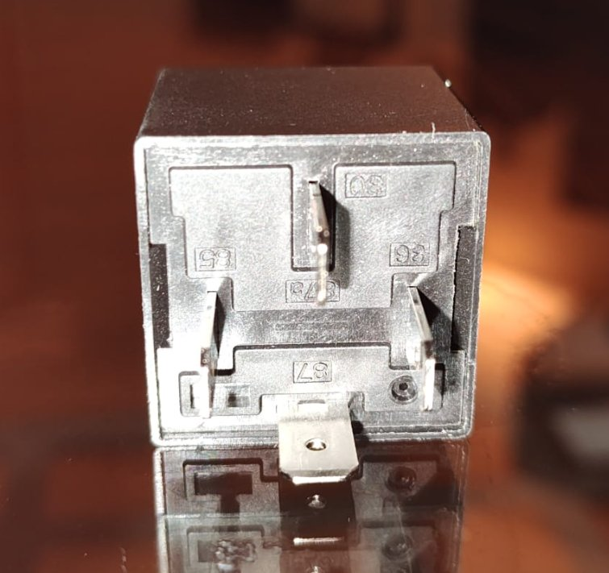 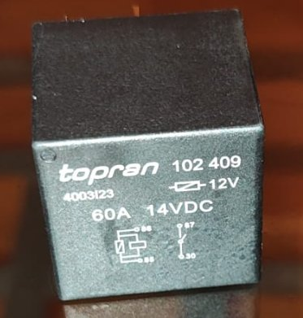
  - 1 4mm2 wire from the relay J47 (connector 87) with a VW 000979243E terminal (Female MCP 4.8k for 4.0mm2 wire) on one side and 2 plugs on the other side which will be connected to the heated windscreen ones.
A plug consists of 1 VW 071973851 connector 4.8 mm + 1 VW 000979307E or N103193.02 male AFS Plus 4.8 Terminal pin for 4mm2 wire + 1 VW 357972842 cavity plug seal 4.8mm, note that the purple plastic inside is a locking mechanism which slides back and forth. 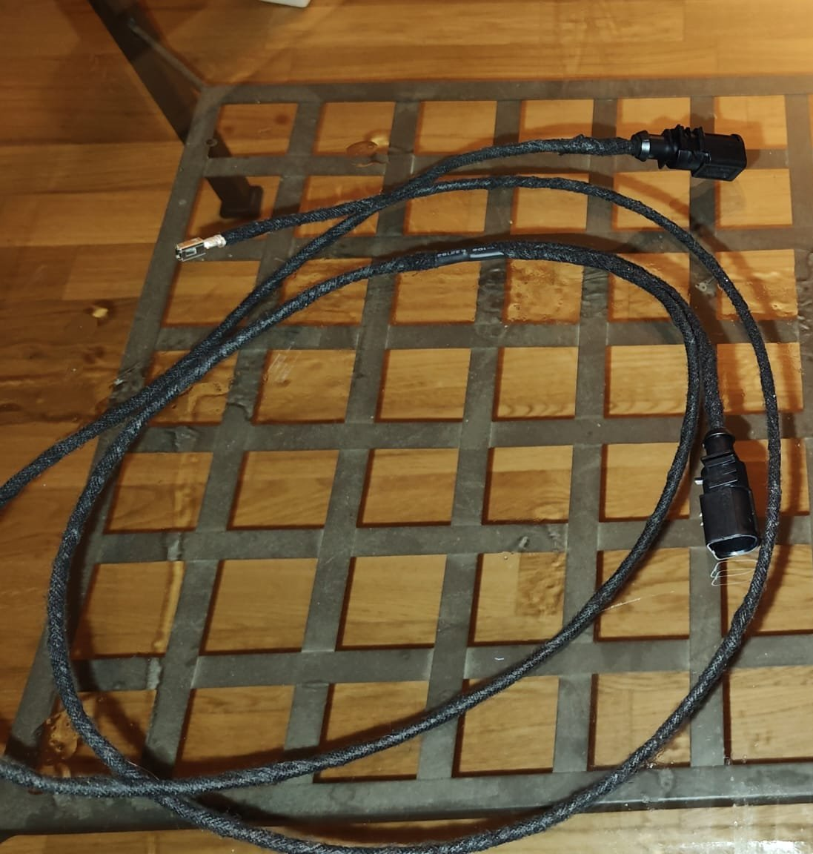 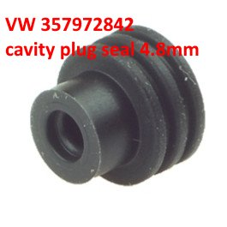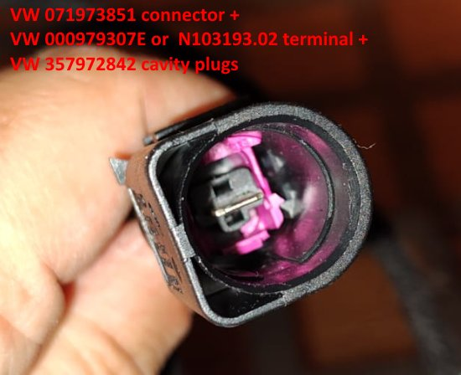 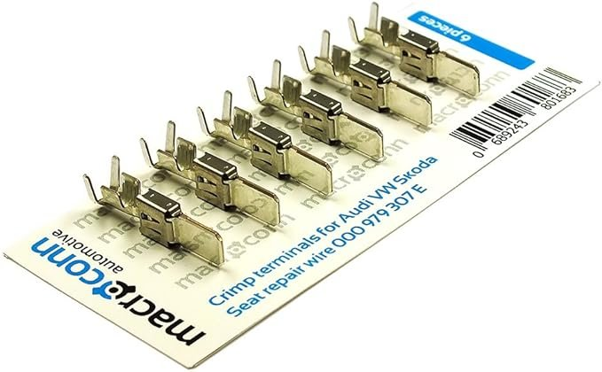
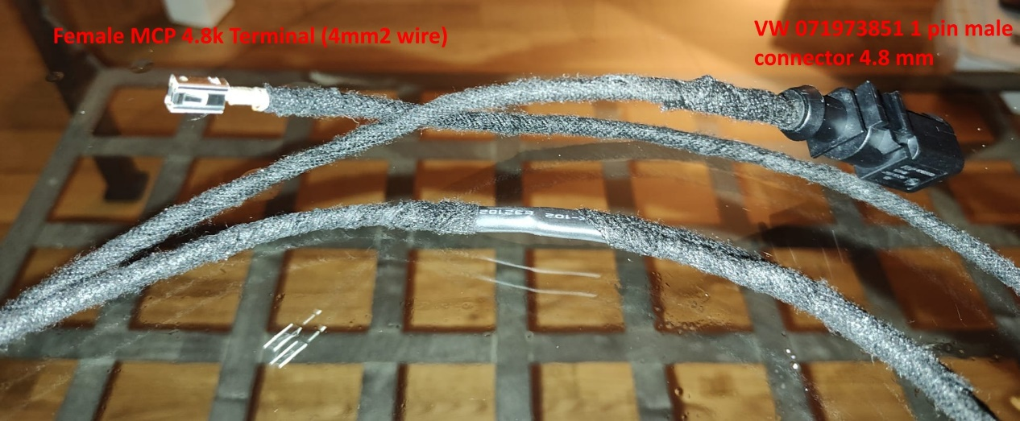
  - 1 0.5mm2 wire from fuse SB17 (or any one empty in the same column, they are all connected to permanent 12V terminal 30, I used SB21) to the relay J47 (connector 85).
On SB17 side there is a VW N90732603 (the picture below is of VW N90696603 which is the same but for 4mm2 wires), a 4.8 female terminal which plugs into the fuse box, whereas on the J47 side there is a VW 000979152E , Female MCP 4.8k Terminal which plugs into the relay plate.
  - 1 4mm2 wire from fuse box b terminal 30 to the JCASE fuse SB14 (40A). Both on terminal 30 and SB14 side there are female 6.3 fastons which plug into respectively the JCASE fuse terminal and terminal 30 of the fuse box.
  - 1 4mm2 wire from the JCASE fuse SB14 (40A) to the relay J47 (connector 30) . On SB14 side there is a female 6.3 faston whereas on the relay side there is a VW 000979243E, a female MCP 4.8k terminal
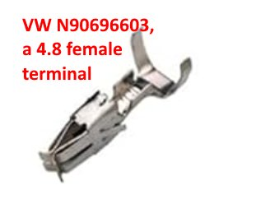

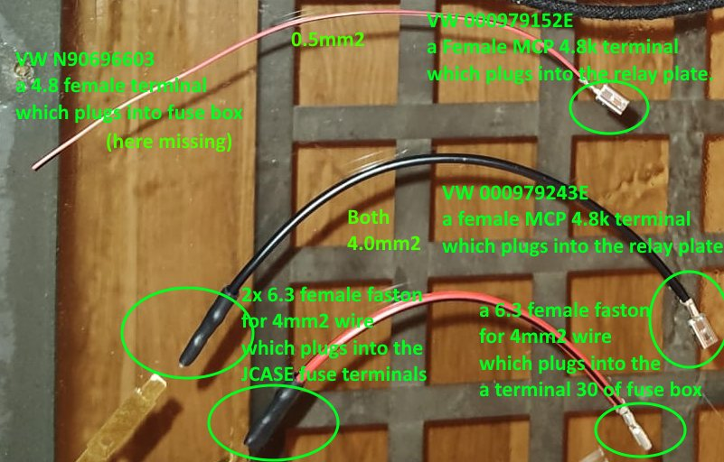

  - 1 0.5mm2 wire from BCM Plug B Pin 26 (inside vehicle cabin near the clutch pedal) to the relay J47 (connector 86). On the J47 side there is a VW 000979152E a female MCP 4.8k terminal which plugs into the relay plate, whereas on the BCM plug B there is a VW 000979009E, a female MQS terminal which plugs into pin 26. 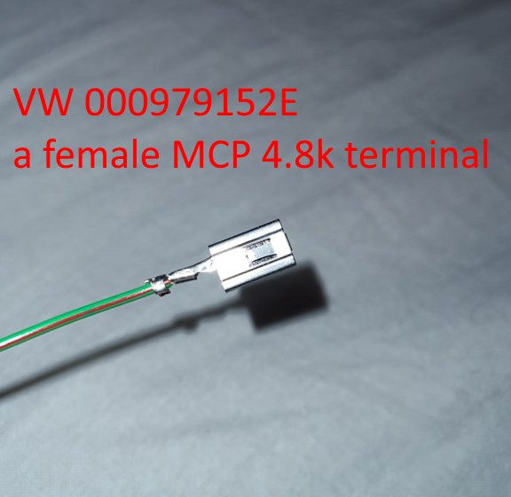
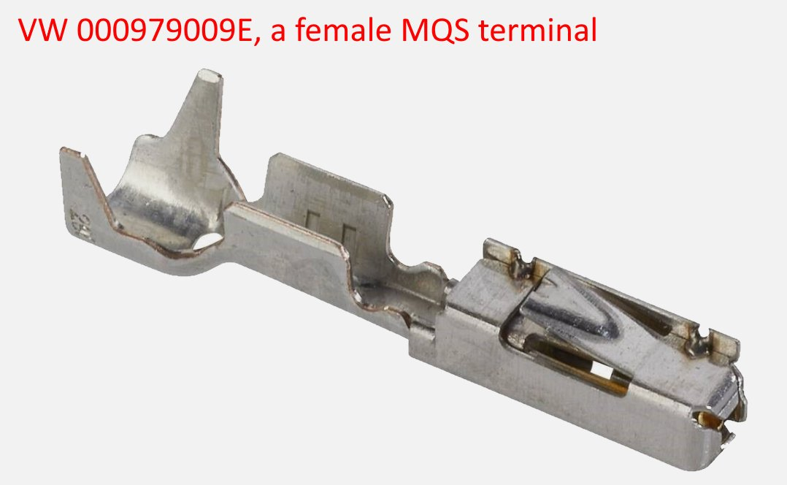
Instructions:
- Disconnect and remove the battery (video: Replacing the Battery - VW Golf MK7)
- Remove lower A-Pillar trim near driver seat (video: https://www.youtube.com/watch?v=dU00cH-WoZg)
- Connect 0.5mm2 wire with female MQS terminal to pin 26 of connector T46b of BCM: you do not have to remove the BCM, with your hands you can disconnect the T46B connector (the one in the middle with 46 pins, whereas A and C have 73 pins). Please note that the every BCM connector has a locking mechanism, a white plastic which rotates down, to be disengaged the red circled black plastic must be pushed a little bit down before turning down the white plastic to unlock. After having disconnected the T46B, you have to open it, split the two halves (upper and lower row of pins) and insert the female MQS terminal into pin 26 and then reassemble and reconnect everything. When reconnecting pay attention to slide first the connector inside the white rail (video: https://www.youtube.com/watch?v=XTiLrowY7Z0 )
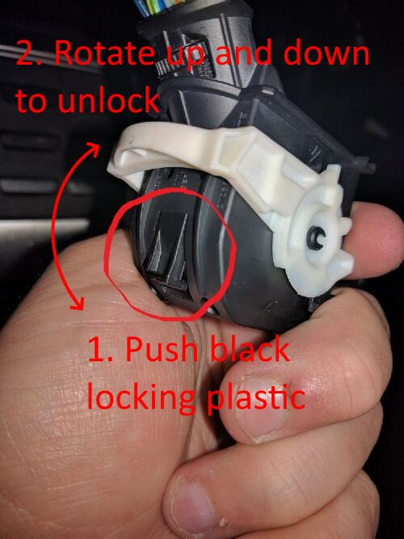
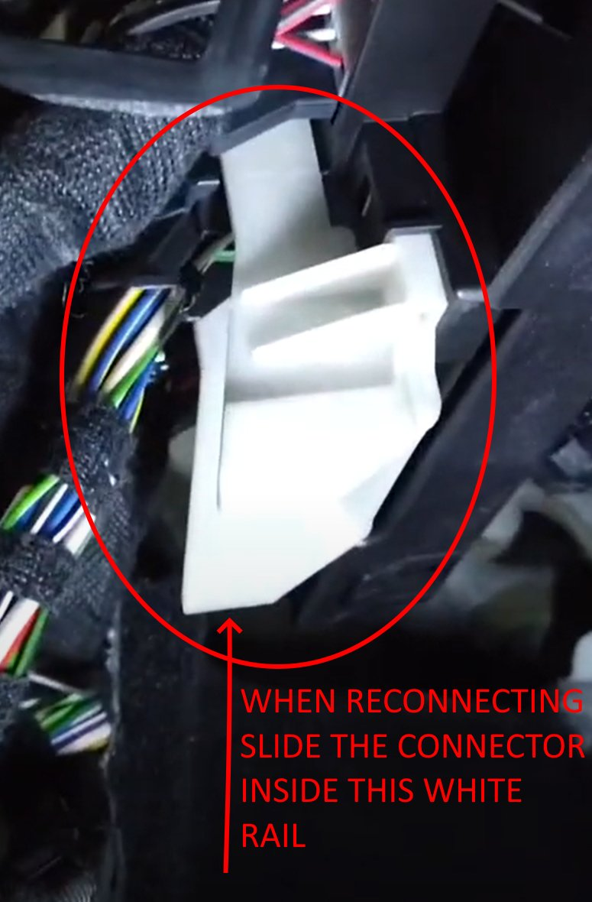
An example picture of BCM removed to get a better understanding
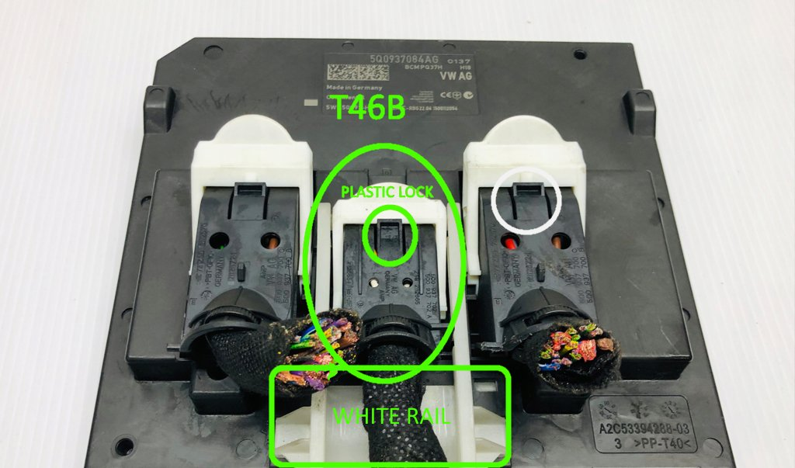Insert female MQS terminal into pin 26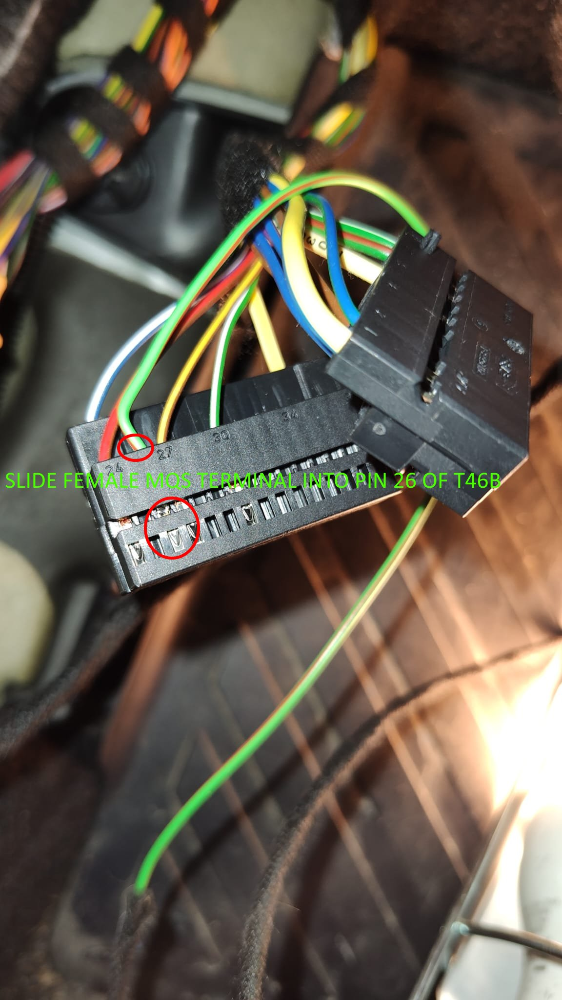
- Run the wire from vehicle cabin into engine bay: you can punch the rubber grommet above the clutch pedal and you will come out just behind the battery (please see www.autoinstruct.com.au/manufacturer/volkswagen/mk7-golf/running-cables-through-the-firewall/ or https://www.youtube.com/watch?v=j_DoT6AGn8E&t=8s or https://www.youtube.com/watch?v=W8Pnv8okMe4).
- Remove Engine Control Module (video: VW Golf 7 engine ECU removal )
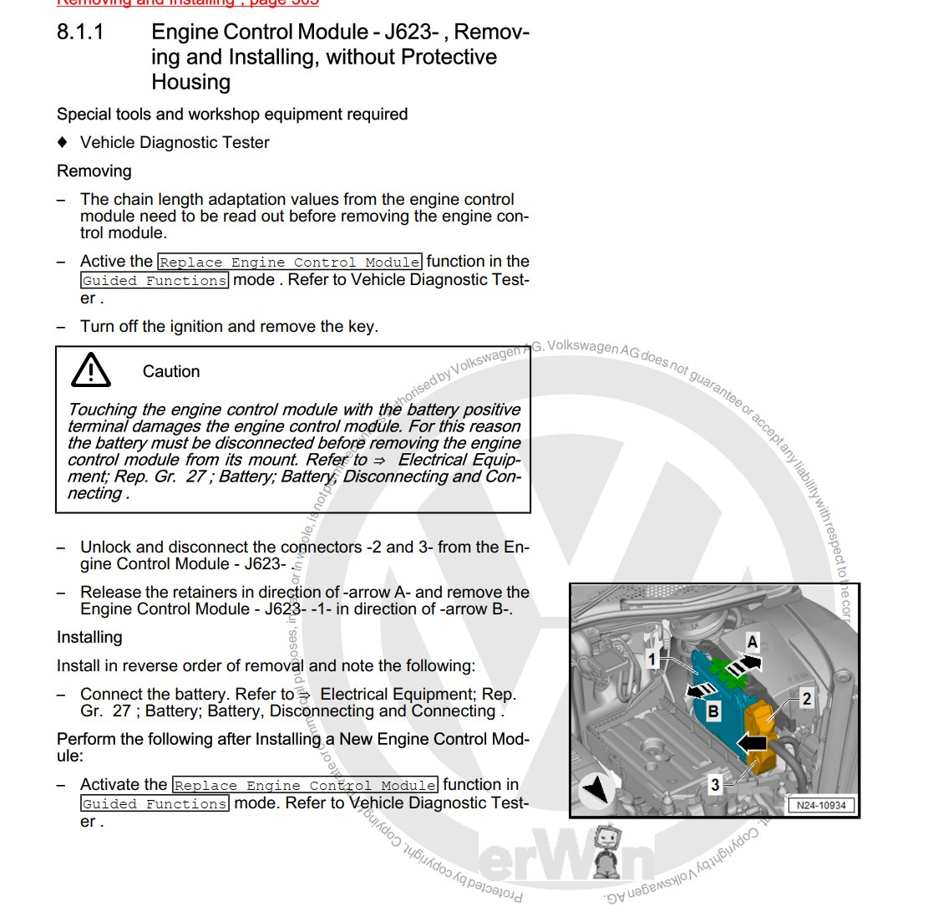

- Remove Fuse Panel B
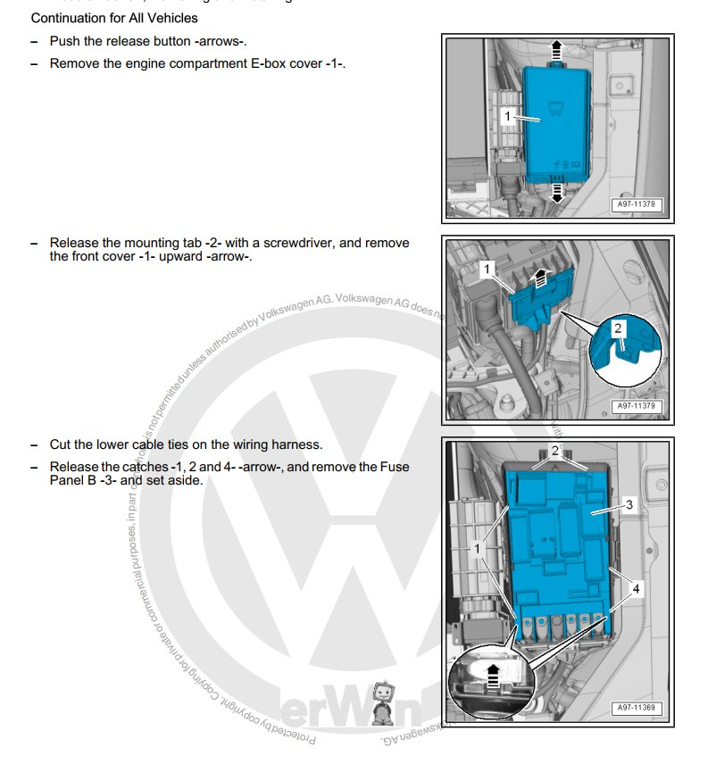
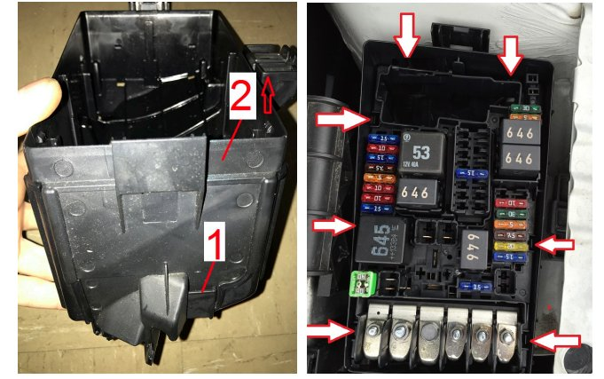
- Insert both JFUSE terminals from behind into the SB14 socket till you hear a click, the pin near the square hole goes up. Insert the female JFUSE.
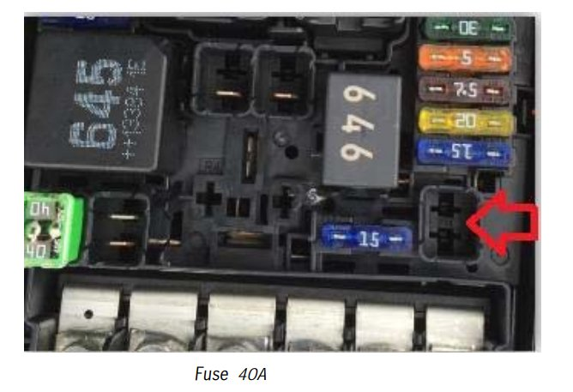
Populated JFUSE 40 plate
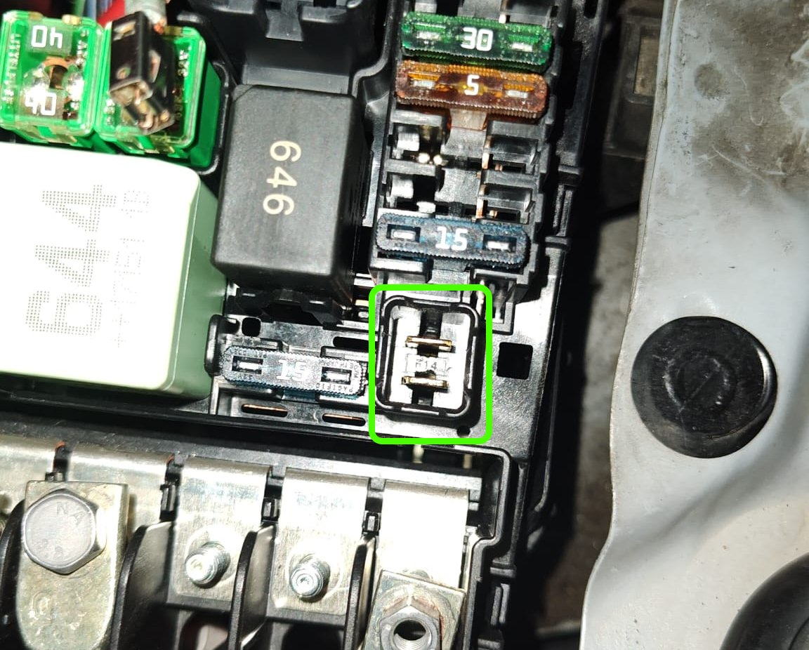
- Connect 4mm2 wire from terminal 30 (female faston) to one terminal of fuse SB14 (female faston)
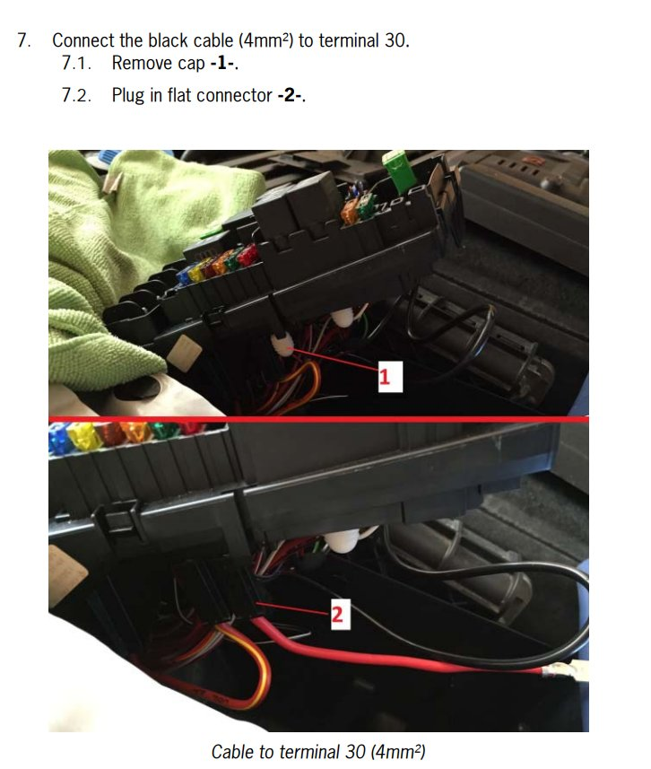

- Connect 0.5mm2 wire to fuse SB17 (female N90732603) or any one empty in the same column (they are all connected to permanent 12V terminal 30, I used SB21), whatever you use please check that the pin on the right is already populated and test its connection with a tester to the previous terminal 30. Plug then 1A, 2A or 5A fuse into the socket (when turning on the heated windscreen on climate controls, the current running through this cable will be far less than 1A).
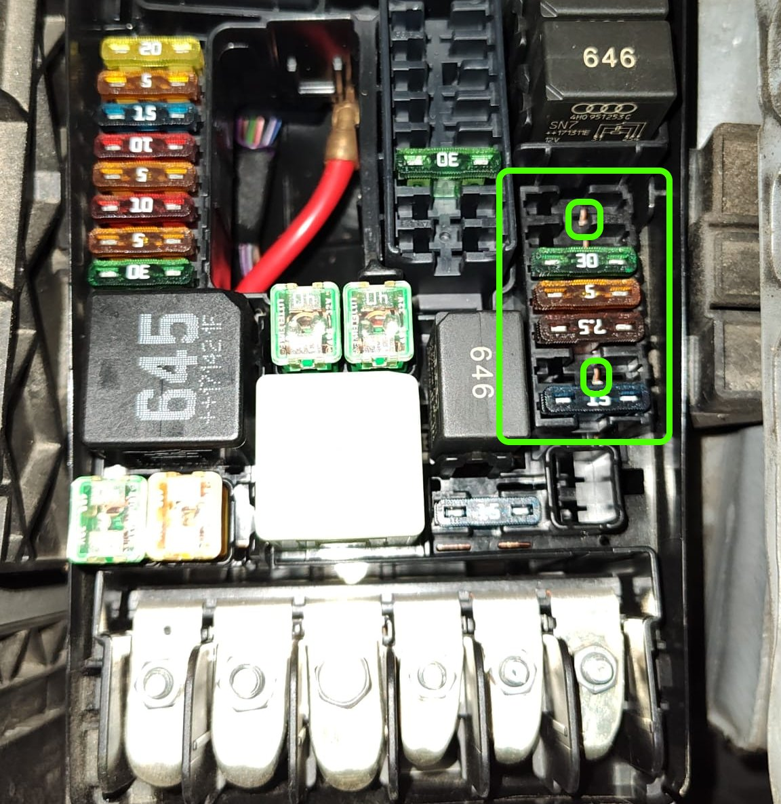
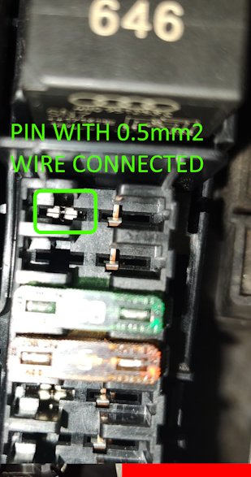
- Insert the relay plate into the fuse box and connect the 3 of the 4 wires to the relay plate from behind in the 4 positions as in the picture below:
- Connector 87 (female MCP): 4mm2 wire to the relay J47 with 2 plugs for the heated windscreen on other side. Do not connect it for now, you have first to lay the cable with the 2 plugs on the bay under the wiper arms (see later).

- Connector 85 (female MCP): 0.5mm2 wire from fuse SB17 (or any one empty in the same column, they are all connected to permanent 12V terminal 30, I used SB21) to the relay J47.
- Connector 30 (female MCP): 4mm2 wire from the other unconnected terminal of JCASE fuse SB14 (40A)
- Connector 86 (female MCP): 0.5mm2 wire from BCM Plug B Pin 26 (inside vehicle cabin near the clutch pedal)
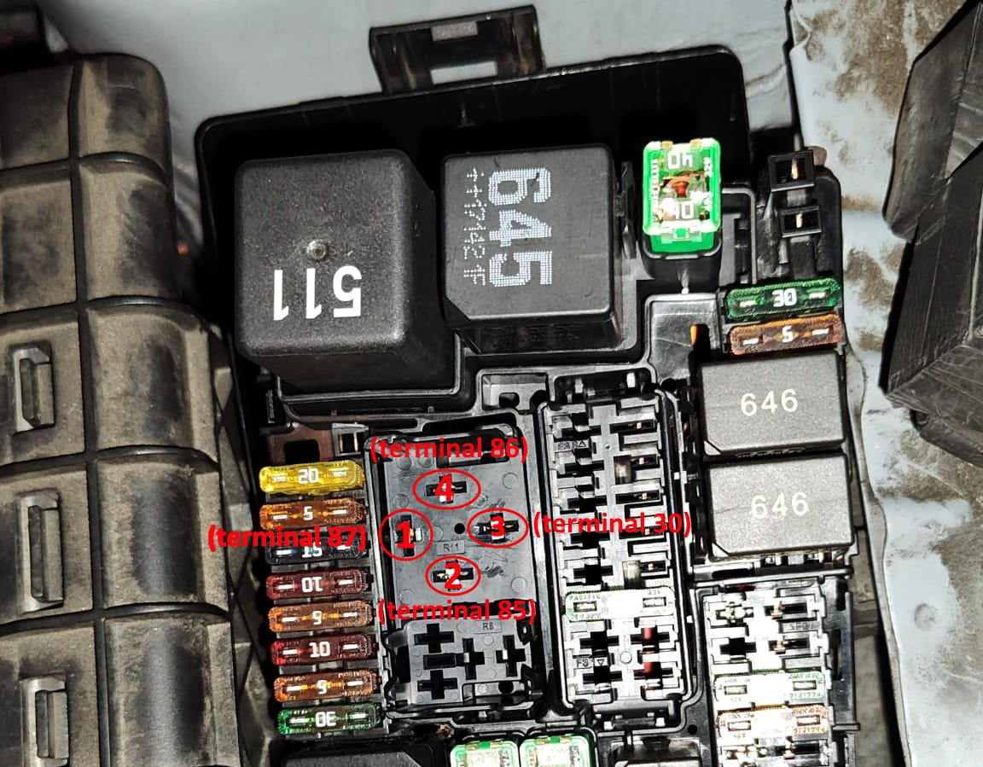
- Remove the wiper blades and arms and its plastic cover to access the bay ( https://www.youtube.com/watch?v=5i6nfktKC24 ). Connect the 2 plugs of the 4mm2 wire to the female VW 071973851 connectors attached to the heated windscreen, run the wire through the bay securing it using the cable holders and zip tying it to the other existing wire. To exit the bay under the wiper arms use the water box (please see the pictures below).

Position of the 2 plugs of the heated windscreen
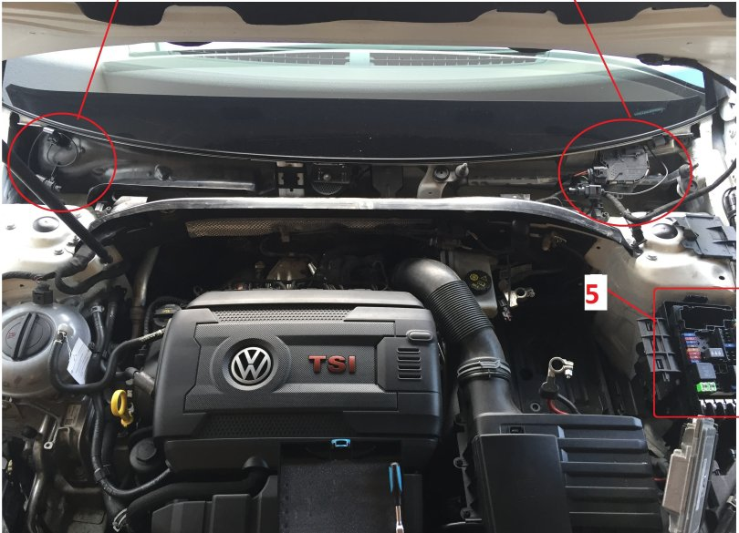
Passenger side holders
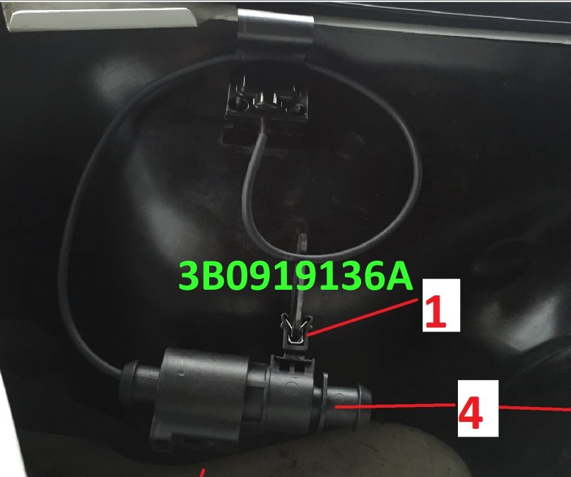
Driver side holders
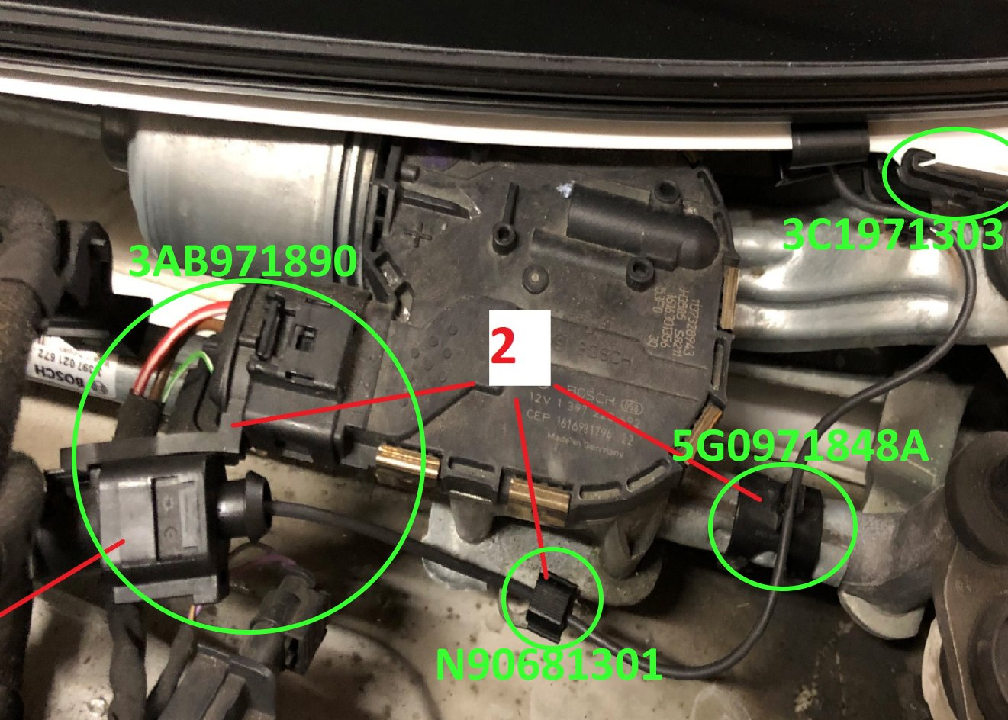
Zip tie the wire to existing cable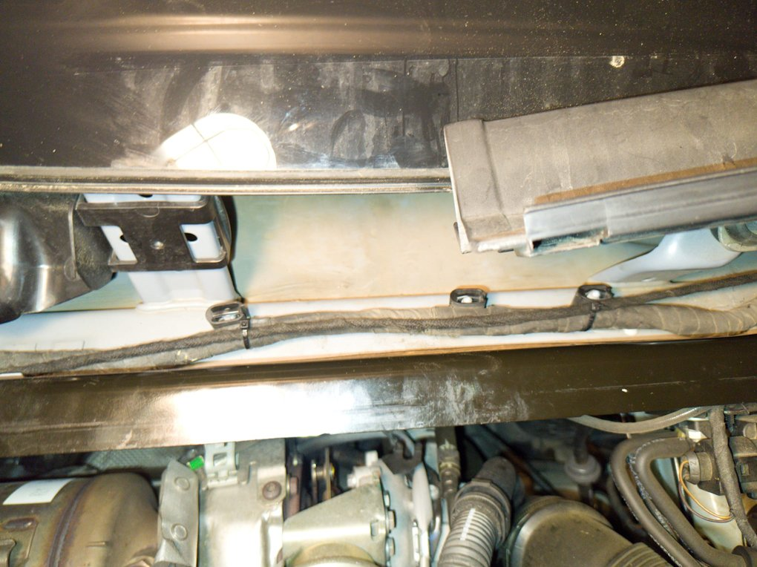

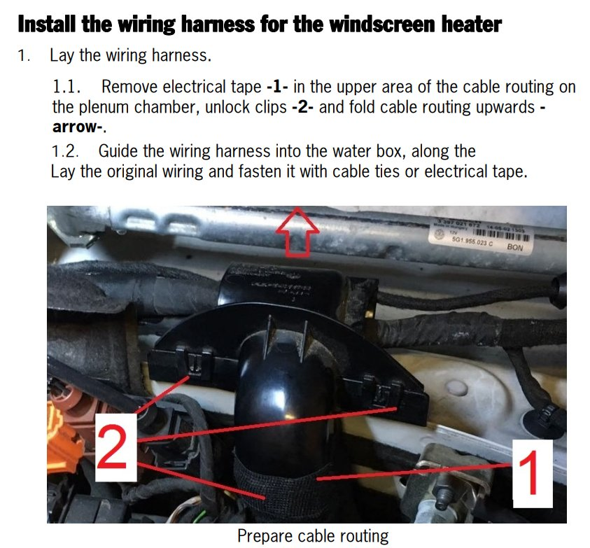
Use a cable entry probe to exit the bay. You have to run the 4mm2 wire with the female MCP connector to terminal 87 of the relay plate inside the fuse box and connect it from behind. Insert then the relay into the relay plate.
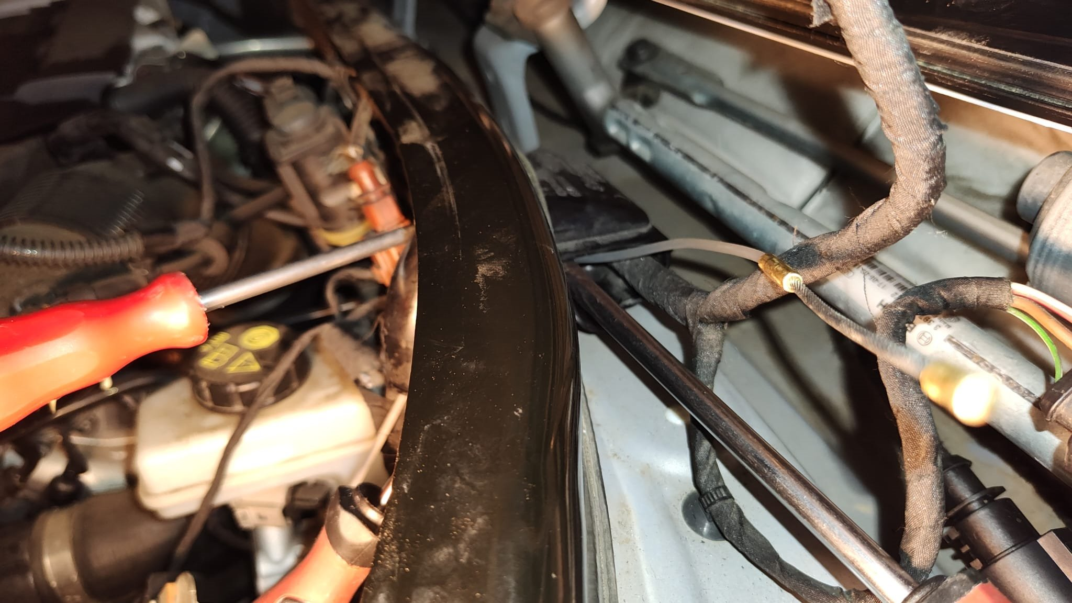
The next step is do the coding
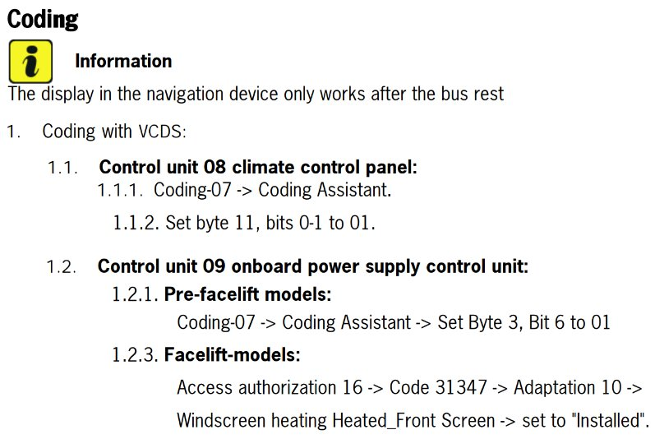
Congratulations all done, test it!
