Volkswagen Golf MK7.5 Facelift Lane Assist Retrofit
PREREQUISITE: The front lane assist camera uses the extended CAN bus, meaning that you must have the HIGH variant of the gateway. If not you must upgrade it before retrofitting, otherwise it won't work.
IMPORTANT: You must disconnect both terminals of the battery, negative first and then the positive before starting this retrofit!

Circuit diagram
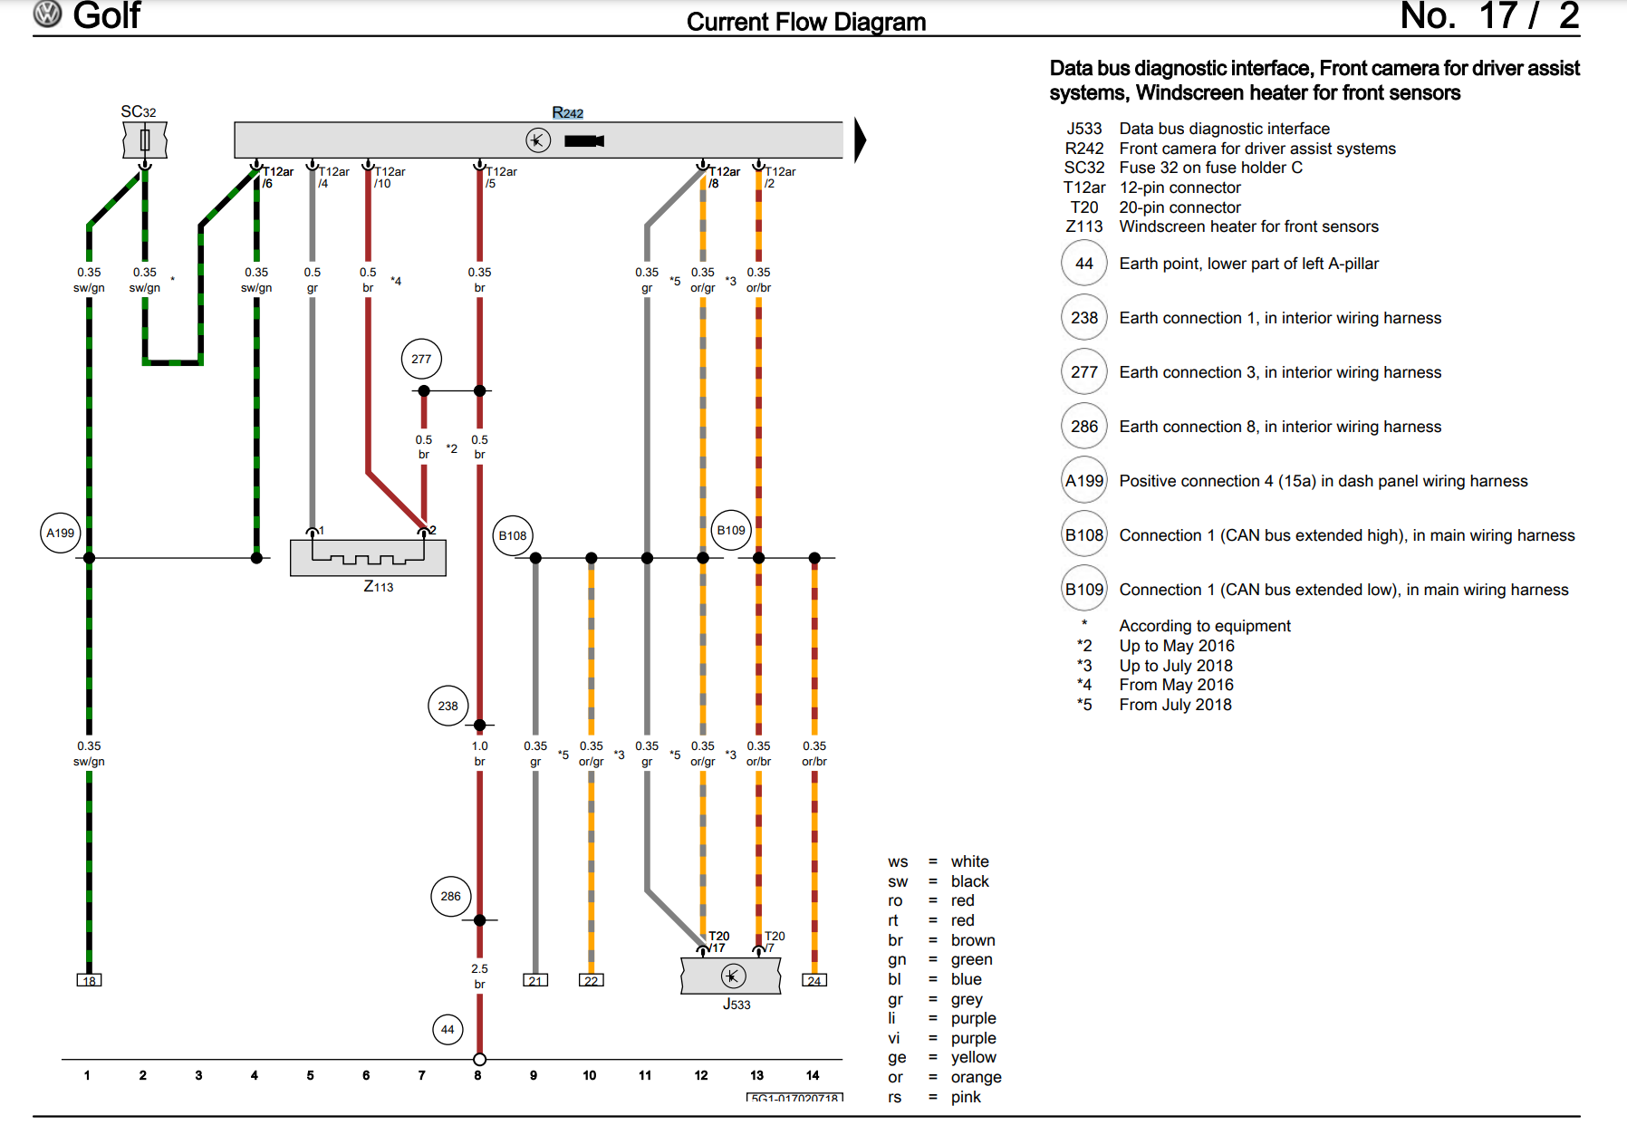

6 wires to be connected
- The brown for the ground (near the camera on the roof)
- The black/green for the 12V power (in the fuse box on the left side of driver seat)
- A connector with two wires to the heating element installed with the new windscreen
- The orange/gray and orange/brown wire have to be connected to the gateway unit (or the T17d/l black connector). Pin T20/17 and T20/7 of the gateway unit (J533) are also connected respectively to T17d-l/12 and T17d-l/13, you can connect the front camera wiring harness also here (easier)
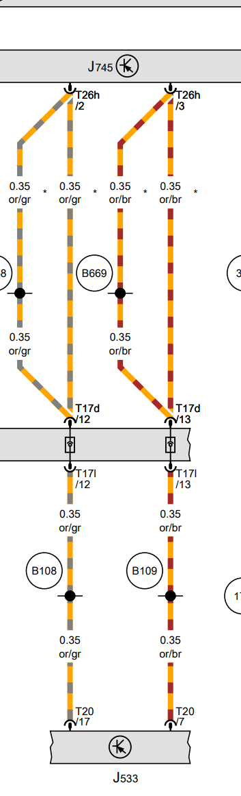
If you have adaptive cruise control you have to connect 2 additional wires, e.g. the front camera T12ar/7 and T12ar/1 to respectively T8ay/5 and T8ay/6 (R242 is the lane assist camera, J428 is the adaptive cruise control, T8ay is the black connector which plugs into the adaptive cruise control radar)
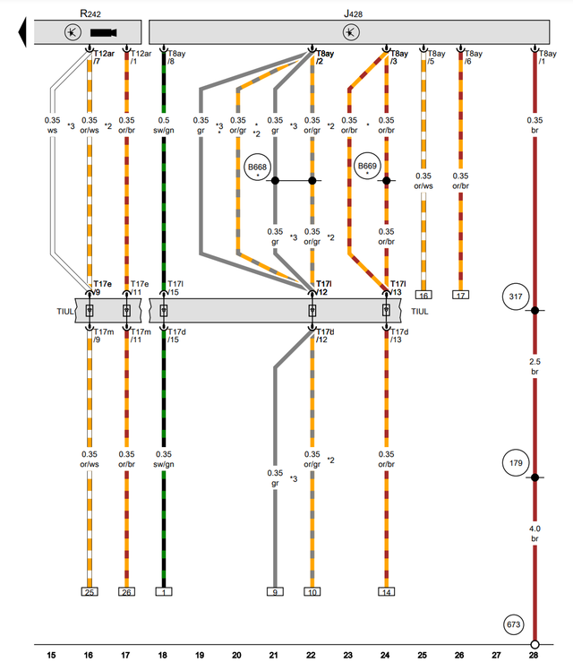
What you need to buy:
- A windscreen with camera support, the most complete windscreen is 5G0845011ARNVB which is heated and has both the camera and rain/light sensor support.
- Wiring harness (https://www.aliexpress.com/item/4001113041051.html), there are two versions of the harness, one if you do not have adaptive cruise control and one if you have, the difference is just 2 additional wires.
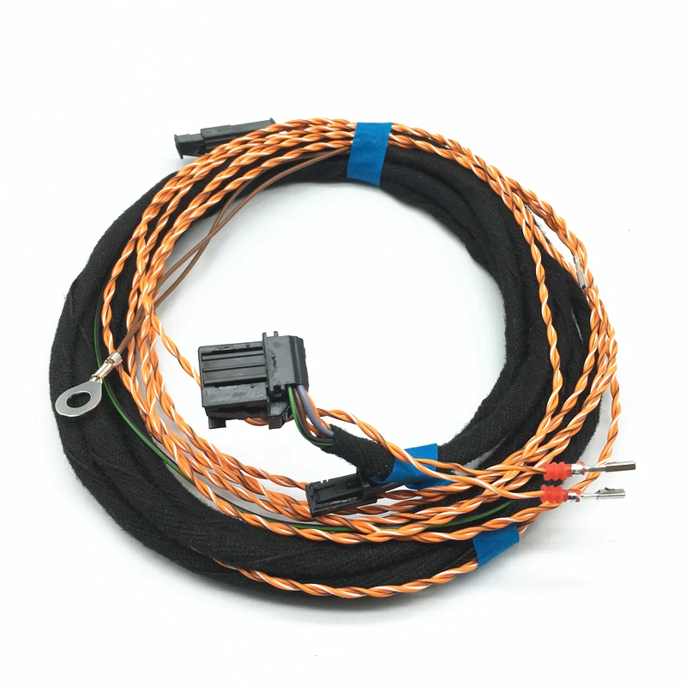
- A front camera 3Q0 980 654 H (used is fine or get it on aliexpress, note this part number is for Golf MK7 facelift, standard Golf MK7 has a different part number)
- Plastic pry tools (https://www.aliexpress.com/item/1005005277284483.html)
- Car terminal removal (de-pinning) tools (https://www.aliexpress.com/item/1005006066487709.html)
- Upper cover of front camera 5G0868437A (Y20 pearl grey, ZA2 shetland, 82V titan black)
- Lower left cover of front camera 3G0858633 (82V titan black)
- Lower right plastic cover of front camera 3G0858634 (82V titan black)
- 2 upper left A-pillar clips 5G0 867 276 B (https://www.aliexpress.com/item/1005005259454106.html), they must be replaced every time you remove the upper left A-pillar trim
- A mini fuse tap with a fuse of 7.5A (or even 5A) (https://www.aliexpress.com/item/1005006156291214.html), to connect the camera to 12V
- Car wiring harness tape to waterproof cable in engine bay (https://www.aliexpress.com/i/1005002147007935.html)
- A spare T8ay adaptive cruise control female connector with pins 4F0 972 708 (https://www.aliexpress.com/item/33002827979.html),it's cheap, you never know what could happen, you can use it to train with unlocking and depinning
- A spare T17d/l female connector with pins 8K0 972 483 (https://www.aliexpress.com/item/1005005342574765.html), it's cheap, you never know what could happen, you can use it to train with unlocking and pinning
Moreover you must have one of these two rear view mirrors, if not you must buy one of them
- 3G0857511AC (rear view mirror, 9b9 satin black)
- 3G0857511AM (rear view mirror, pzi shetland/satin black, sma satin black/pearl grey, 9b9 satin black)
General overview video: https://www.youtube.com/watch?v=I2hk7vTIvNM

Steps:
- Remove rear-view mirror (https://www.youtube.com/watch?v=lIGOHgjXj2c)
- Remove the light dome (https://www.youtube.com/watch?v=1OrI577sG9Y and https://www.youtube.com/watch?v=B6FdSKlwuxc )
- Remove the upper A-Pillar trim near driver seat (https://www.youtube.com/watch?v=wQ0nc0kvkoA)
- Remove the driver seat item compartment (https://www.youtube.com/watch?v=mw4wC7yznSI)
- Remove lower A-Pillar trim near driver seat (https://www.youtube.com/watch?v=dU00cH-WoZg)
- Start laying out the wiring harness from the camera support on windscreen
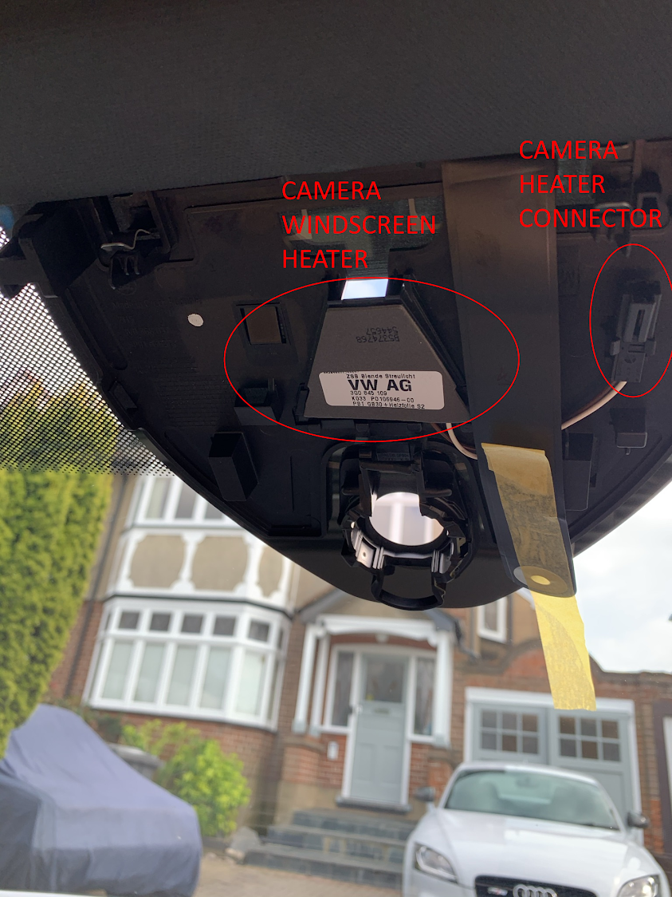

- Connect the brown wire to the ground bolt in the light dome, the 2-pin connector to the camera heater on the windscreen, do not install the camera and connect the 12-pin connector (T8ay) to it for now (wait till the end).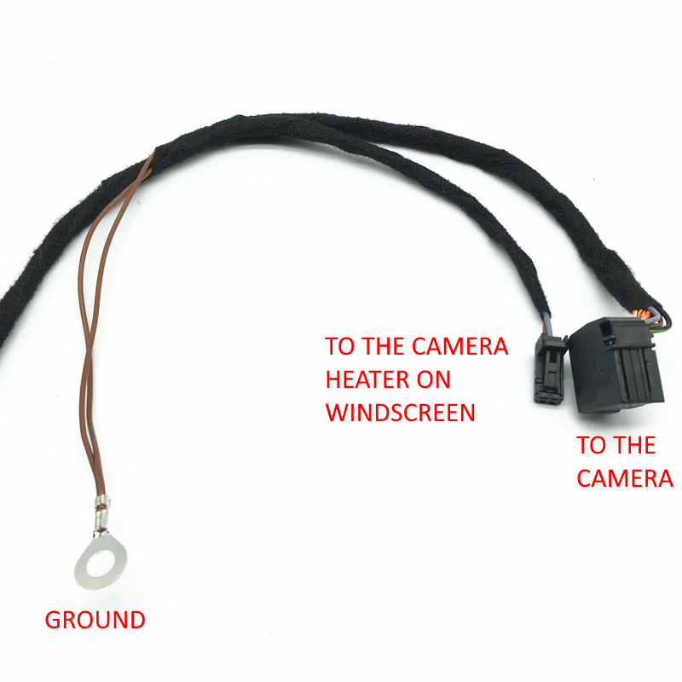
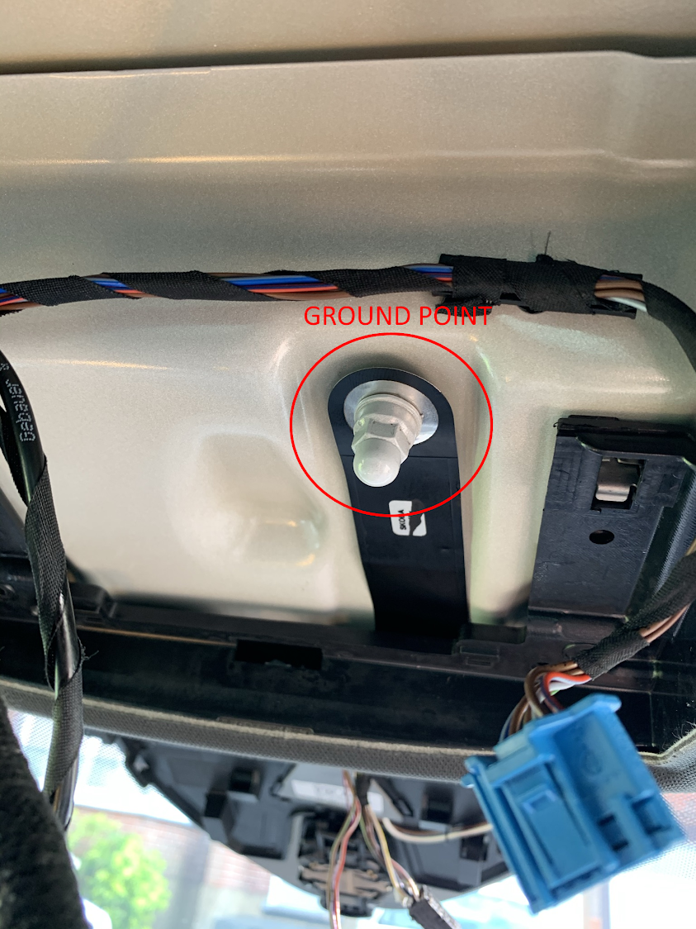
- Run the wiring harness to the fuse box near the driver seat, passing it inside the roof, down the upper A-pillar and zip tying it to existing cables (to get an idea you can watch https://www.youtube.com/watch?v=SSNWBijc8mg and https://www.youtube.com/watch?v=vRzV4vKY1r4).
Connect the black green wire using a mini fuse tap to SC32 fuse or if unable due to space to another fuse in the same row (https://www.youtube.com/watch?v=59uL9jNEI1k).
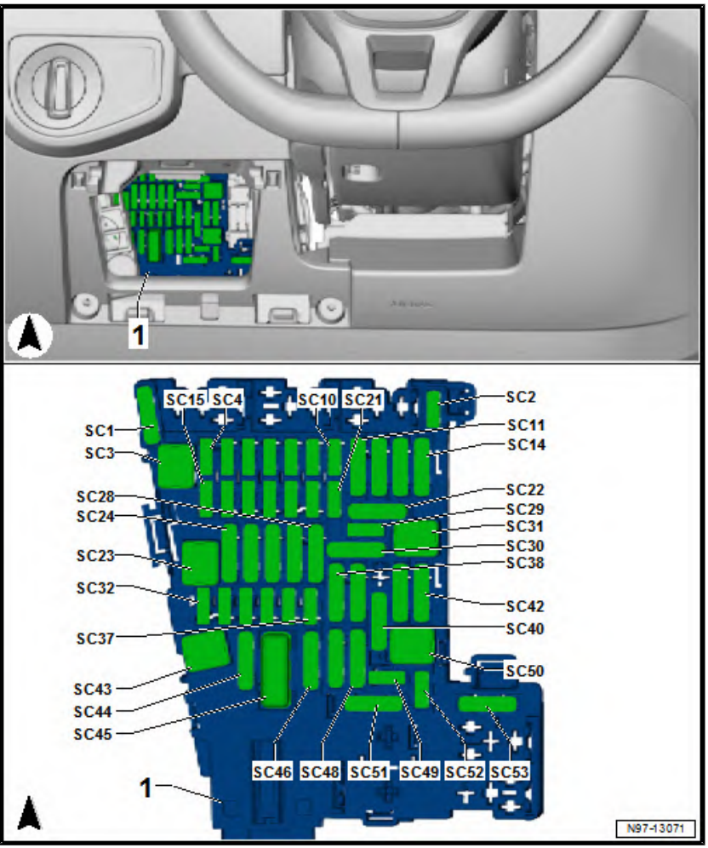

- Run the wiring harness to the TUIL connector in the lower A-pillar, take out the T17d/l female black connector (pull first the upper red clip on the top to allow removal).
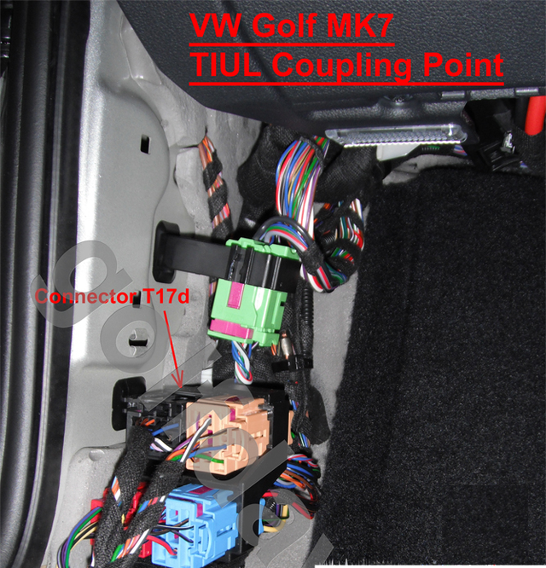
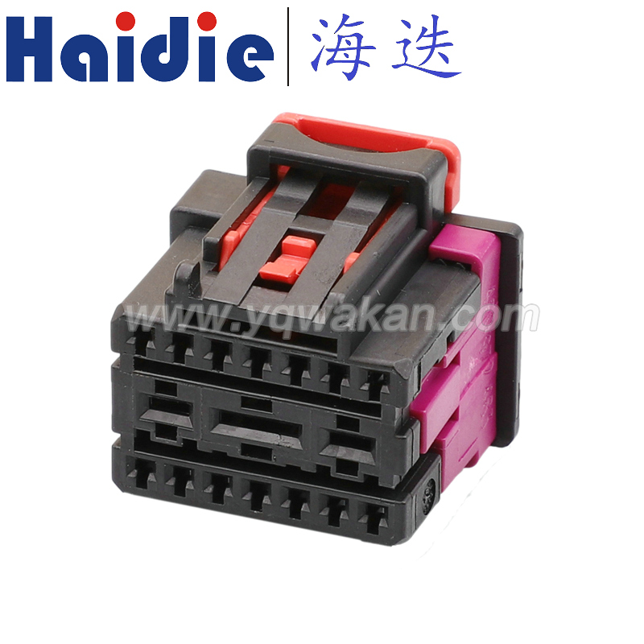

You have then to de-pin pin 12 and 13 using the car terminal removal tools after having unlocked the purple lock on the connector (please see https://www.youtube.com/watch?v=5rlXZUvhEsQ)
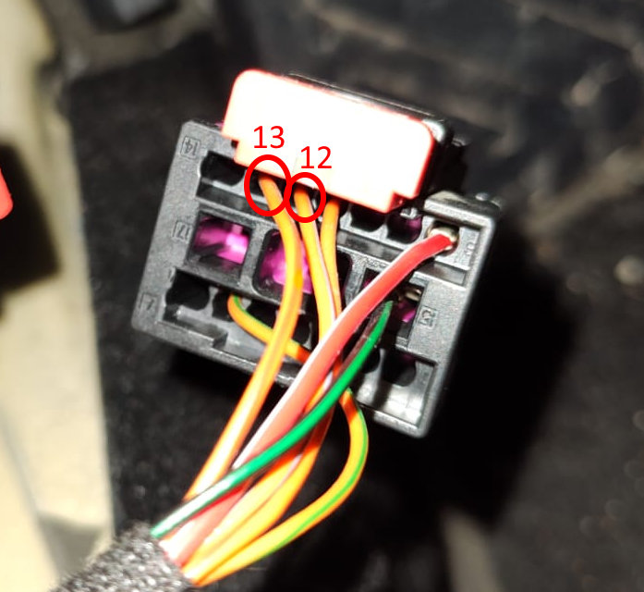

You have to connect these two pins to the empty 2 pin connector provided with the wiring harness and in turn connect the two nearby spare pins to the T17d/l black connector, you have to respect the electric diagram above (you can use the wire colors).
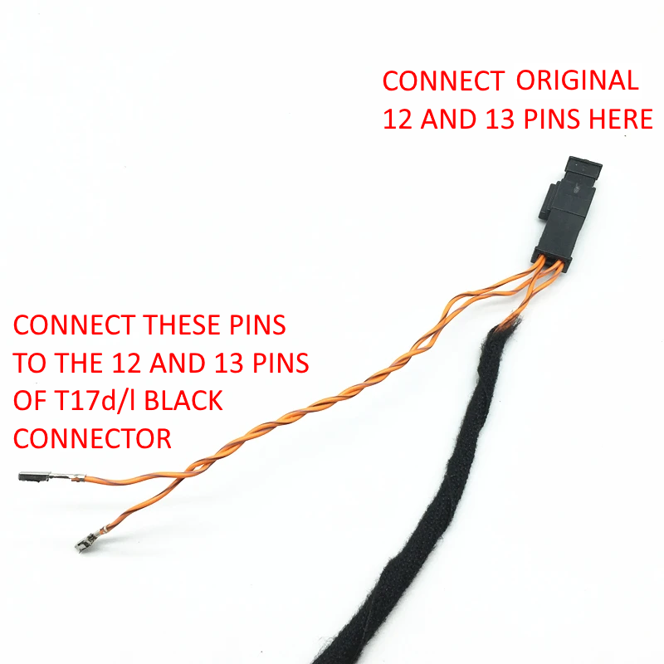

Final result
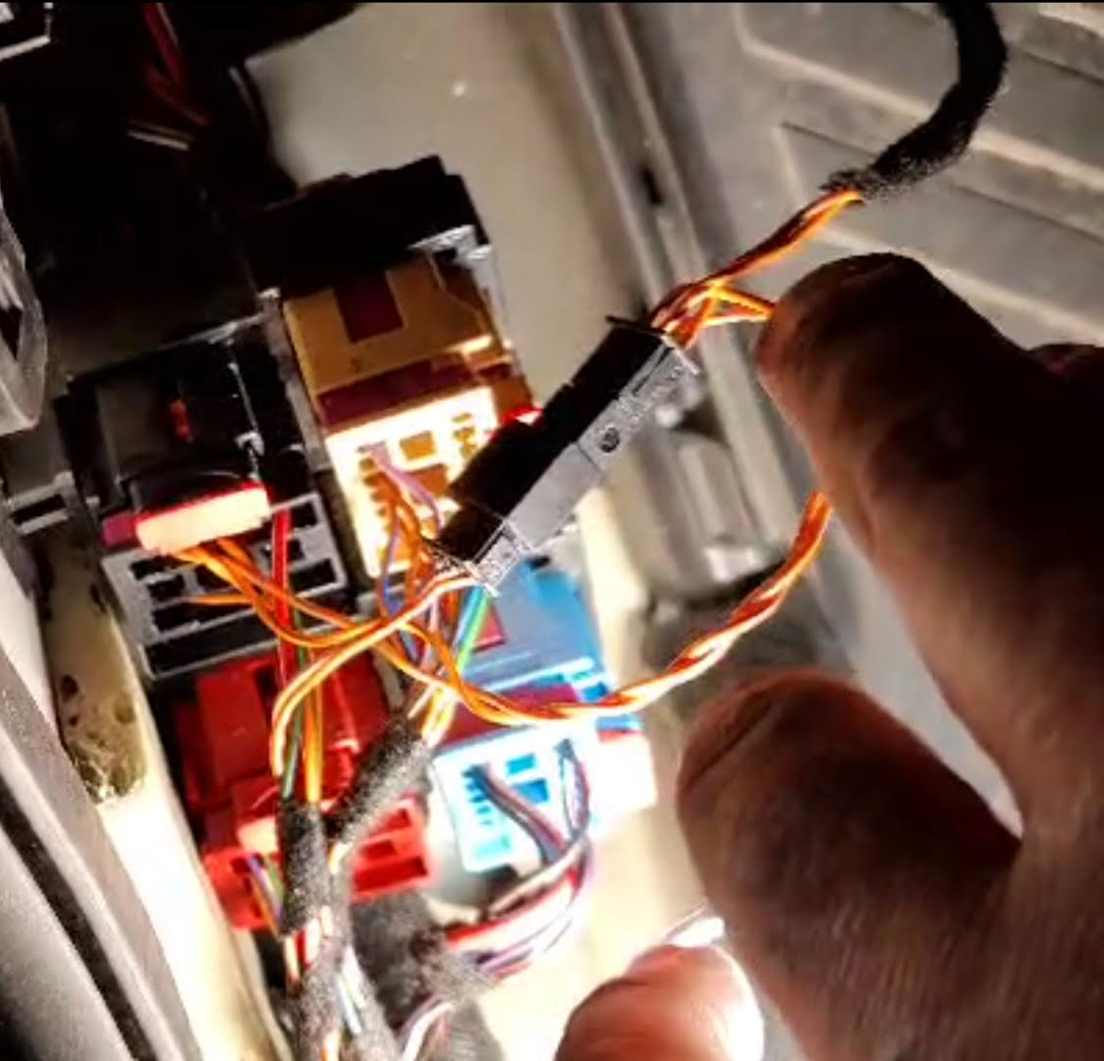
This is the most critical connection point, in order to avoid issues in your car you must double check the connection with a tester, you can use a sewing pin to probe pins of a female connector:
  - Test that the original CAN bus line is not broken, e.g.
    - Test that the original orange-grey cable plugged into the above empty connector is still connected to pin 12 of the T17d/l black connector
    - Test that the original orange-brown cable plugged into the above empty connector is still connected to pin 13 of the T17d/l black connector
  - Test that the lane assist camera connection is fine, e.g.
    - Test that pin 8 of the lane assist camera connector on the windscreen is connected to pin 12 of the T17d/l black connector
    - Test that pin 2 of the lane assist camera connector on the windscreen is connected to pin 13 of the T17d/l black connector
Camera connector near camera support on the windscreen
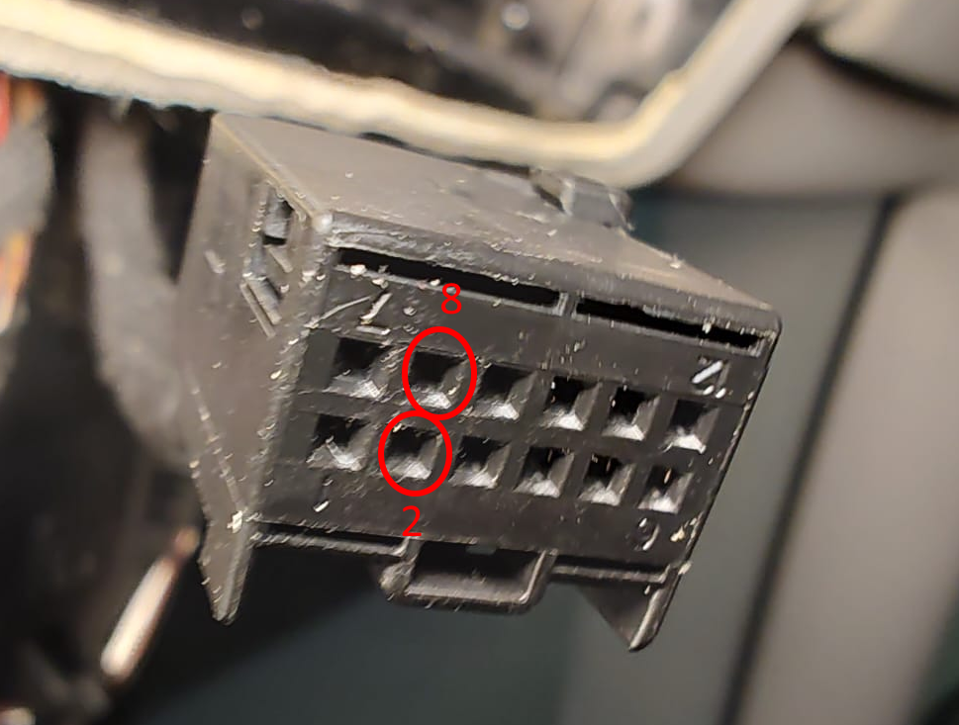
- If you have adaptive cruise control you must also:
  - Remove the battery
  - Remove the adaptive cruise control grille (https://www.youtube.com/watch?v=2XAw_byXNFM)
  - Connect the two additional wires (orange/white and orange/brown) of the lane assist wiring harness to adaptive cruise control connector in the engine bay (orange/white wire to pin 5, orange/brown wire to pin 6): to run the 2 wire twisted cable (do not untwist it!) from vehicle cabin into engine bay you can punch the rubber grommet above the clutch pedal and you will come out just behind the battery (please see www.autoinstruct.com.au/manufacturer/volkswagen/mk7-golf/running-cables-through-the-firewall/ and https://www.youtube.com/watch?v=j_DoT6AGn8E&t=8s, https://www.youtube.com/watch?v=W8Pnv8okMe4). You can run the wire down under the right side of the battery, come near the right headlight and finally along under the adaptive cruise control grille. I strongly advise however to tape the last part of the 2 wire twisted cable with wiring harness tape in order to make it more water resistant (water o rain can come in from the front grille). To insert new pins inside the ACC connector you have first to unlock it by sliding the green lock (there are 2 green locks, one of each row of pins).
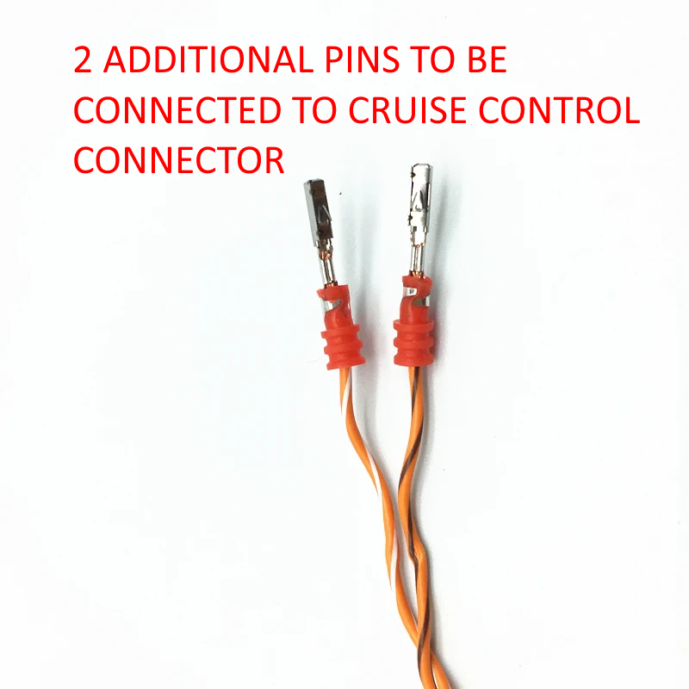
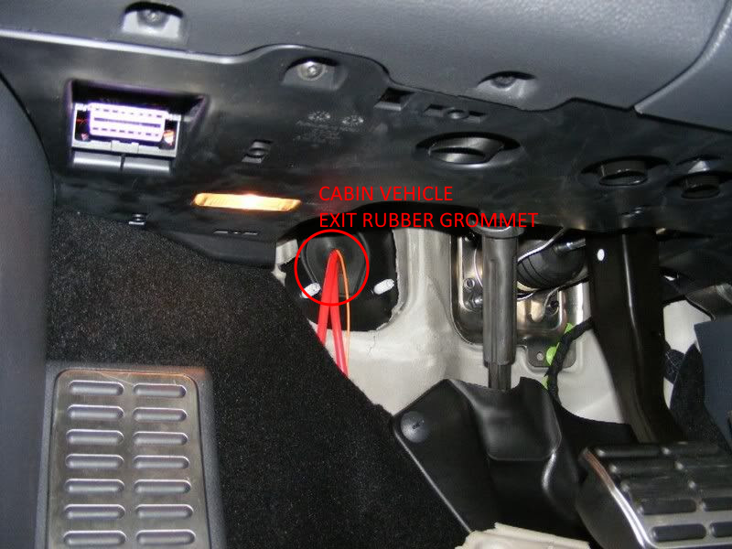
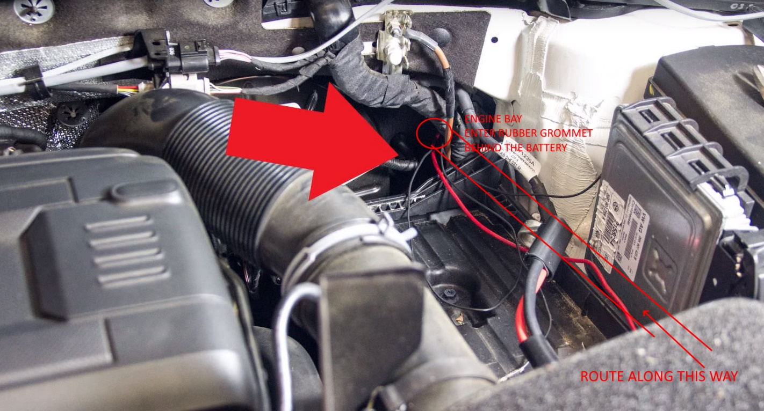
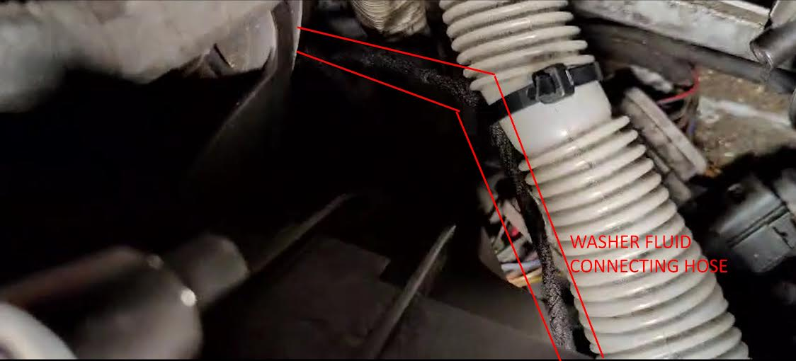
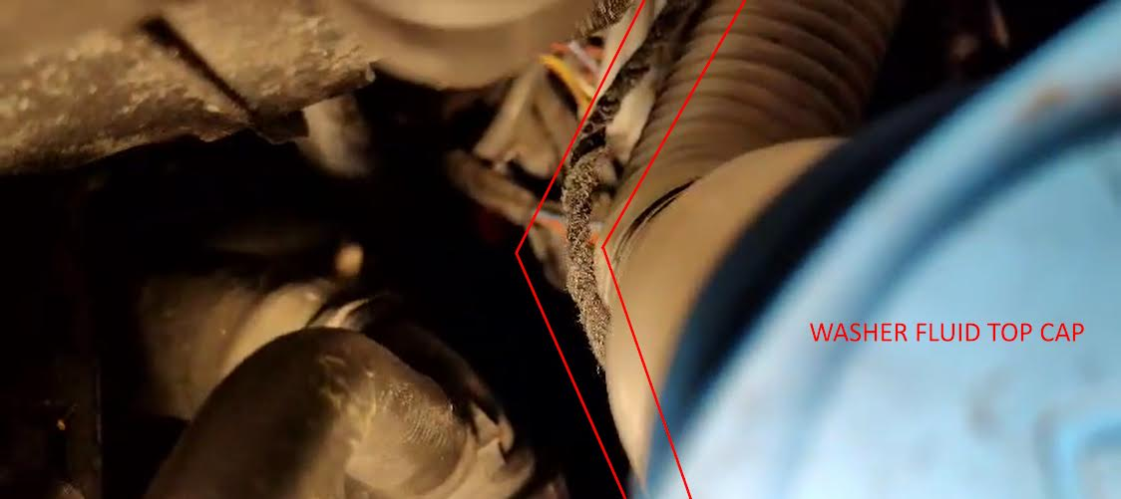
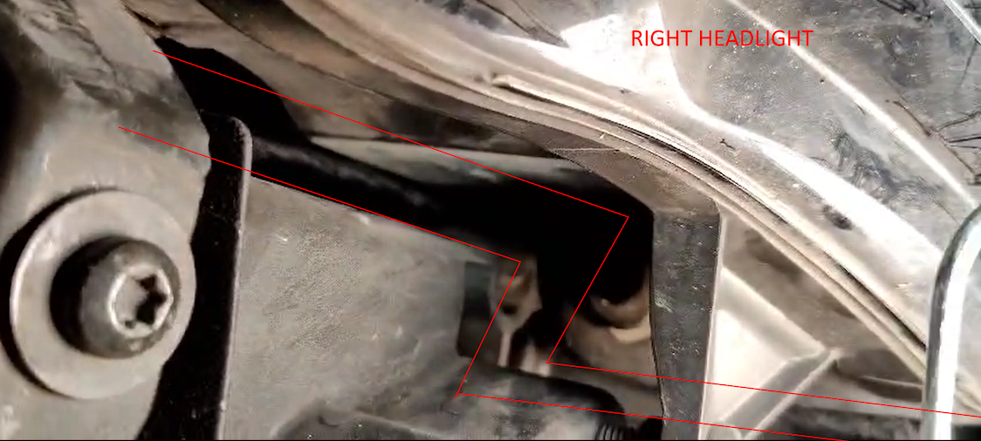
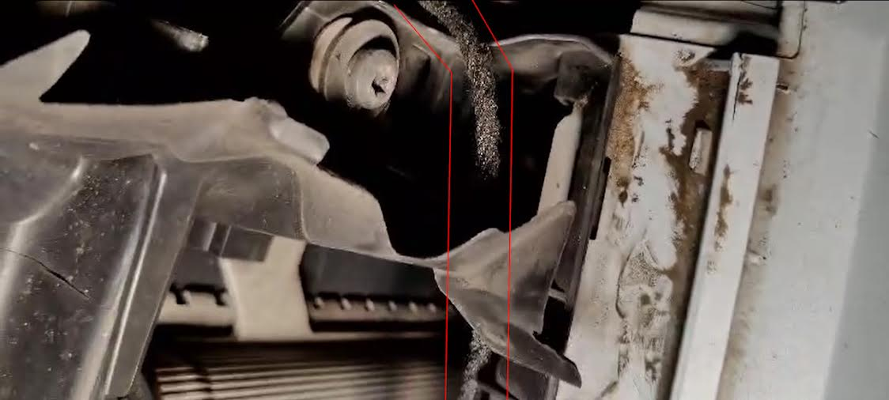
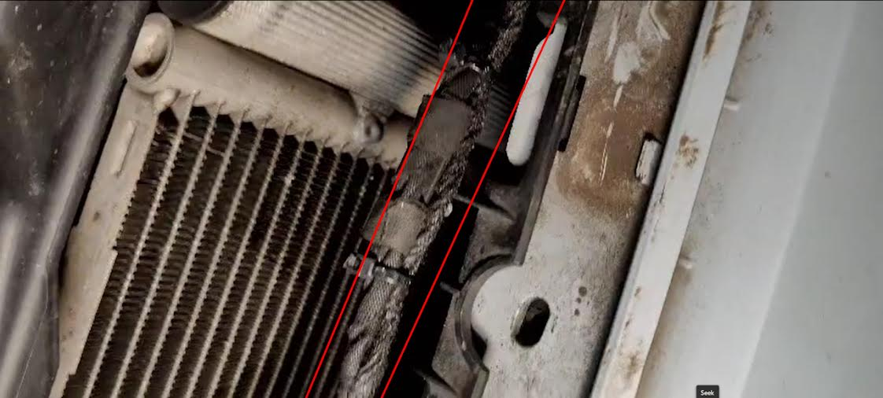
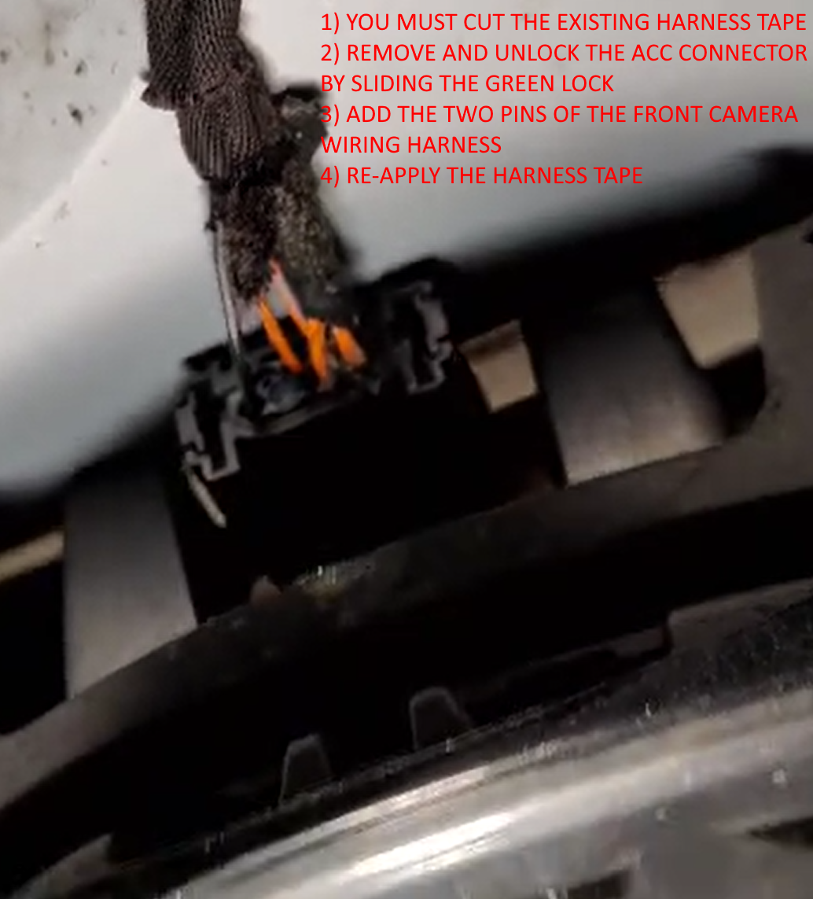
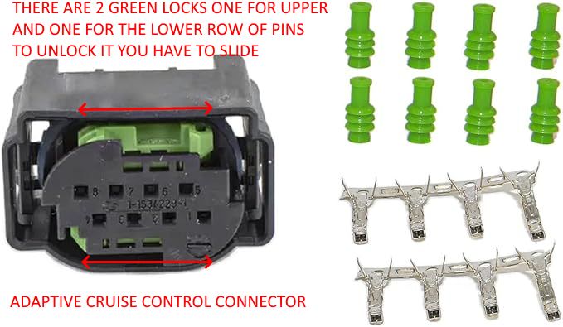
Well done, you have almost finished the retrofitting, you still need to:
- Do the coding using OBD11 or any tool you have (you can google for Xagico VW Golf MkVII pdf)
- Check that A5 control unit has only 2 faults "No Basic Setting" and the obvious component protection (CP) due to the new control unit, both these errors will be solved after having done the calibration procedure
- Perform ADAS calibration (front camera, adaptive cruise control, etc.) at a local car glass center
All done!

Camera calibration – general information
Calibration is the process of determining both extrinsic and intrinsic camera parameters (like camera coordinates, focal length, optical center) once installed. It is a mandatory process needed to perform any kind of calculation on an image, like measuring a distance between pixels, estimate depth or 3d structure. It is performed using a predefined calibration pattern consisting of a sheet where a set of objects of a predetermined shape (like squares, circles, etc.), size and position is put in front of the camera at a precise distance.
Every camera manufacturer has its own calibration pattern; for Volkswagen it is called VAS 6430. Usually, you have to perform calibration at carglass centers where they have all the needed equipment, but if you are skilled enough and you know what you are doing you can perform it by yourself using either official VW ODIS (guided procedure) or OBD11, I quote here an untested OBD11 procedure which I found on a Skoda owner website:
- Position the car in front of the calibration pattern like in the picture below (distance is in mm)
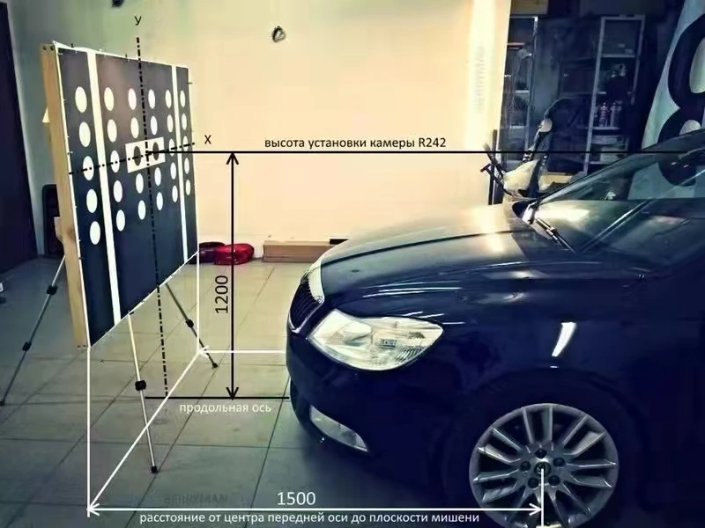
- Measure 4-wheel arches and go to module A5 Front Sensors Driver Assistance System performing the security access with the code 20103
  - Change diagnostic service --> VW
  - Go to Adaptation (confirm all values!)
    - Body height wheel house edge-Body height left front wheel house edge --> Enter value
    - Body height wheel house edge-Body height right front wheel house edge --> Enter value
    - Body height wheel house edge-Body height left rear wheel house edge --> Enter value​
    - Body height wheel house edge-Body height right rear wheel house edge --> Enter value
    - Distance to calibration field --> Enter 1500
    - Calibration target position --> Just confirm
    - Axel offset --> Just confirm
  - Go to Basic Configuration
    - Search calibration target
    - Initial online configuration
    - Static calibration costumer service
  - Change diagnostic service --> End of assembly line
  - Basic Configuration --> Static calibration end of assembly line
If everything is fine the fault about "No basic settings" should be removed and this marks the end of the static calibration (called static because the car is not moving).
Since this calibration is never perfect the lane assist camera A5 after this phase enters another calibration phase called dynamic because it is performed automatically by the camera while you drive (you have to drive for at least 500 kms), the more you drive, the better the calibration will be fine-tuned, you can check this in the Live Data menu option (Dynamic calibration, status and Dynamic calibration, details).

